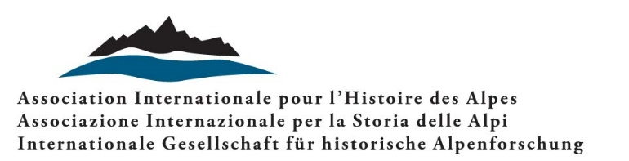

Prix Bergier

IAAH “Jean-François Bergier” Prize for research in Alpine History (2026)

Announcement

The Prix Bergier is promoted and awarded by the International Association for Alpine History (IAAH), in memory of Jean-François Bergier, the scholar who promoted and co-founded the Association. The Prix Bergier is awarded every two years and aims to promote research by young scholars on the history of the Alps - and European mountain areas in general.

Art. 1 - The Prix Bergier is awarded to doctoral theses, having as their central object the Alpine and pre-alpine area or other European mountain realities. Theses must relate to Medieval, Modern or Contemporary History, in one of its fields of study (social, economic, cultural, demographic, environmental, technical, etc.), or to neighbouring disciplines, though limited to historical anthropology and geography and medieval and modern archaeology.
Art. 2 - Doctoral theses written in one of the following languages are eligible for the Prix Bergier: French, Italian, German, Slovenian or English.
Art. 3 - The Prix Bergier 2026 will be awarded to a single doctoral thesis that meets the requirements set out in Articles 1 and 2, and which was defended in a viva between 01.01.2024 and 31.12.2025.
Art. 4 - The thesis must be submitted in digital format no later than 15 January 2026 at the following address: info.aisa@usi.ch. It must be accompanied by an official document from the University of reference certifying the defence date of the doctoral thesis and the candidate's successful viva.
Art. 5 - The Prix Bergier consists in co-financing the publication of a volume based on the prize-winning doctoral thesis, with a publisher of the prizewinner's choice. The publication must be freely accessible on the web and must make explicit reference to IAAH’s being the co-publisher and co-financer, as well as indicate the IAAH award of the Prix Bergier. The Prize also includes an invitation to present the prize-winning work at the biennial IAAH conference, with travel, board and accommodation expenses covered for the duration of the conference. The Prix Bergier is officially awarded at said conference.
Art. 6 - The Jury will comprise the IAAH scientific committee and the experts appointed by the same committee to assess each of the theses received. The Jury’s judgement is final and unquestionable. The Jury reserves the right not to award the prize in the absence of contributions deemed meritorious.
Art. 7 - The evaluation criteria for doctoral theses for the award of the Prix Bergier are as follows:
- Relevance to Alpine and mountain history
- Novelty and originality of the research
- Use of unpublished archive sources
- Scientific relevance of the topic and contribution to the discipline
- Methodological rigour
- Clarity and style of exposition
- Quality of the graphic and iconographic apparatus
- Relevance and exhaustiveness of the bibliography
- Other particular qualities
Art. 8 - The documentation sent by candidates will not be returned.
Art. 9 - By entering the competition, candidates automatically accept all the articles of this announcement.

Prof. Aleksander Panjek Prof. Luigi Lorenzetti
IAAH President IAAH Secretary

