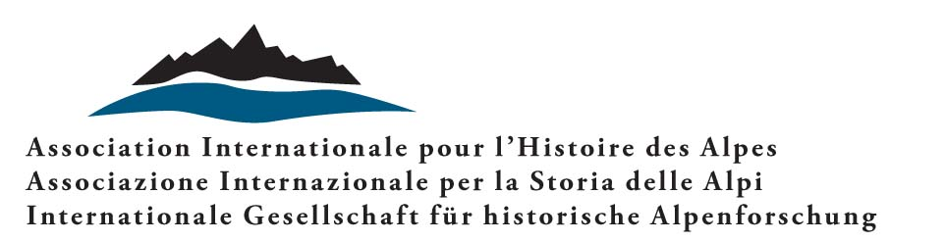 |  | 

The Environment at the Summit

Actors and representations of the safeguard of nature in mountain areas:
a global perspective (late 18th – early 21st century)

Call for papers

Conference of the International Association for Alpine History
In conjunction with
the Department of Contemporary History, University of Fribourg

Mendrisio 3–4 September 2026

«Environmental degradation is a threat that permeates into the beautiful mountain regions of the world, the Himalayas and the European Alps. Similar processes can be observed in the Andes and in Northern Africa. In the Alps, despite a wide range of measures taken during the last century to cope with the destructive forces of water, they face new indications of environmental degradation»

The passage quoted above is taken from a brochure published in 1989 by the Himalayan Adventure Trust (renamed Himalayan Environment Trust in 1990), a non-profit organisation whose Committee comprises renowned mountaineers and members of the Mountain Protection Commission of the International Mountaineering and Climbing Federation. The organisation aims to promote initiatives designed to safeguard the environment of the Himalayas. However, it does not focus exclusively on this region. The progressive degradation of mountain environments, in fact, has led it to broaden its perspective to take in all mountain areas of the planet. Thus, it pays particular attention to issues such as soil and water pollution, and the widespread presence of waste or litter.
Prompted by publications on environmental issues in mountain areas (e.g., Debarbieux e Rudaz, 2010; Denning, 2015; Mathieu, 2019; Hagimont, 2022; Boscani Leoni et al., 2022; Fleetwood, 2022), and follow-up from the research project «La mondialisation des Alpes, du paysage à l’environnement», which was carried out between 2022 and 2026 at the Department of Contemporary History, University of Fribourg, with the support of the Swiss National Science Foundation, we would like to organise an international scientific conference with the aim of studying the progressive integration of the environmental protection theme into the several mountain ranges of the Earth, between the end of the 18th century and the beginning of the 21st century, concluding in 2022, the International Year of Mountains. By selecting a global perspective, it encourages a decentring of observation points, which in turn brings to light not only the diversity of trajectories but also the possible (direct or indirect) circulation of knowledge, materials, practices and individuals in the different mountain ranges.
Taking the practice of mountaineering as an interpretation key – while its relation to the environment continues to be relatively neglected by historiographers – the objective is to explore three fields of analysis: its actors, its representations, and its limits. In this regard, the following questions may be addressed (further questions may then be added):
- Which actors (single and collective) are involved in this topic? What are their expectations and recommendations? In what way do they plan to put in place or carry out such requests?
- How do they define the problem? What do they want to champion? What representations of nature do they refer to?
- What possible hurdles are they facing in the implementation of their ideas? And finally, can the limits of the process be identified?

Practical information

The conference will be held on 3 and 4 September 2026 in Mendrisio (Switzerland) at the Laboratorio di Storia delle Alpi LabiSAlp (Università della Svizzera italiana-Academy of Architecture). The official languages of the Conference are French, Italian, German, and English.
Please submit your proposal, together with title of the paper and an abstract of approximately 500 words, no later than 1 November 2025 to: claude.hauser@unifr.ch and philippe.vonnard@unifr.ch.
In view of the papers being published and in order to animate the debate during the conference, speakers are invited to send the organisers a text of about 30 000 characters (spaces and notes included) by 15 August 2026.
The papers selected after double peer review will be published in volume 32/2027 of Histoire des Alpes – Storia delle Alpi – Geschichte der Alpen.
Accommodations and meals will be taken care of by the organisers. As to travel expenses, if not covered by the participants’ own institutions, application for reimbursement may be made to the organisers. Refund may be granted (in part or in full) depending on the number of claims received. Priority will be given to young researchers.

Organising Committee

The Conference is organised by:
Claude Hauser, Université de Fribourg
Philippe Vonnard, Université de Fribourg - Université de Lausanne.
In conjunction with:
Luigi Lorenzetti, Università della Svizzera italiana - LabiSAlp co-ordinator; Simona Boscani Leoni, Université de Lausanne; Lucia Leoni, Université de Fribourg; Maurizio Raselli, Université de Fribourg.
For any questions, please contact: philippe.vonnard@unifr.ch

