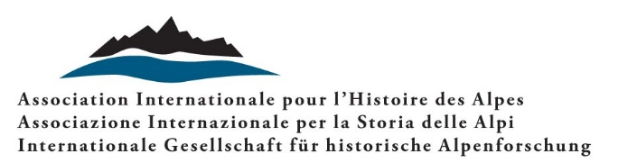

Call for Papers

Families in the Alps
Households and relatives, neighbours and friends – social and economic relationship networks

International conference, Ljubljana, 29-31 August 2024

The Alps have been an almost classic research area for social anthropological, especially American, studies on villages and families, dealing with property and inheritance, etc. since the 1960s, some of which were already quantifying. Previously, population-geographical demographic studies – such as the “Innsbruck School” – had also been carried out on some Alpine valleys. Intense and controversial discussions in the Alpine context revolved around, among other things, homeostatic concepts. These questioned about a possible connection between population and available resources in the sense of a demographic-economic balance or the limits of population growth, based on marriages and births as essential factors. More open and broader approaches rejected environmental deterministic perspectives and referred to options for agency, pluri-activity and integrated economies.
With the international boom in research on family history since the 1970s, questions from historians have also focused on household composition and work organization, on differences and implications of inheritance laws and practices, on specific migration and marriage patterns and also historical-anthropological topics. Here and there, mountain regions stood out due to specific household constellations: for example, the presence of stem families in the narrower sense, in which fathers continued to hold the power, authority and economic position in their hands, even after a son or daughter had married into the house; or shared fraternal inheritance and complex households with several married brothers; or household-heading women and absent men due to gender-specific seasonal mobility. Overall, studies have been able to illustrate the diversity and complexity of families and households.
From the 1990s onwards, approaches further expanded: the “household” was virtually dissolved and differentiating perspectives were introduced: the focus was now more on individual positions (as wives and husbands, sons and daughters, siblings, grandparents, etc.), on genders and generations, based on contractual arrangements linked to legal and administrative frameworks. Various property, inheritance and matrimonial property regimes were connected to one another by historians. Above all, relatives, but also other social relationships that went beyond the household - such as neighbors, friends, guardians and others - were now the focus of interest. The social spectrum of studies, too, has expanded and differentiated. This includes landless people as well as rural craftsmen and traders, agricultural producers and pluri-active workers as well as peasant and other elites.
The planned conference of the International Association for Alpine History is based on these differentiations. We will question the meaning, effectiveness and modes of action of fundamental relationships - represented by families, relatives, neighbours, friends and others - in different social and economic contexts of Alpine societies. This addresses work and wealth relations, competing interests as well as alliances and collaborations. In this perspective, authors are invited to present papers on local or regional case studies from a synchronic or diachronic perspective, discussions of concepts and models specific to (Alpine) family history based on their own research, inter-Alpine comparative studies or papers that combine two or more of these approaches. The time span covered by the conference ranges from the end of the Middle Ages to the early contemporary period (early twentieth century). The papers can be presented in Slovene, Italian, French, German or English.
In selecting the proposals received, the organizers will take into consideration the relevance and originality of the themes as well as the equal representation of the regions of the Alpine area (roughly the regions included in the Alpine Convention) and the chronological period foreseen by the conference. Contributions relating to other European mountain areas that concern the themes and approaches presented in this call may also be accepted.

Margareth Lanzinger e Aleksander Panjek

Please send a thematic proposal (200–250 words) and a short CV by 31 January 2024, to the following address: aleksander.panjek@fhs.upr.si

